**Queries for insert:**

*insert into bank_details(ifsc_code, bank_name, Location, branch_manager) values*

*('GER01FRFT','Bank of Germany','Frankfurt','Rick Stue');*

*insert into company_branch(branch_id, branch_head, city, number_of_employees,country) values ('GER100','Simon','Frankfurt',100,'Germany');*

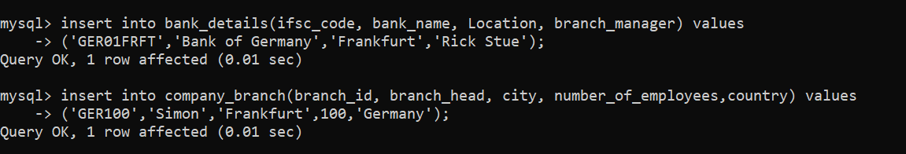

==================================================================================

**Queries to update:**

*update official_data set designation ='Vice President' where emp_id = '10003';*

*update project_details set years_of_contract = 2 where project_id = 'prj0023';*

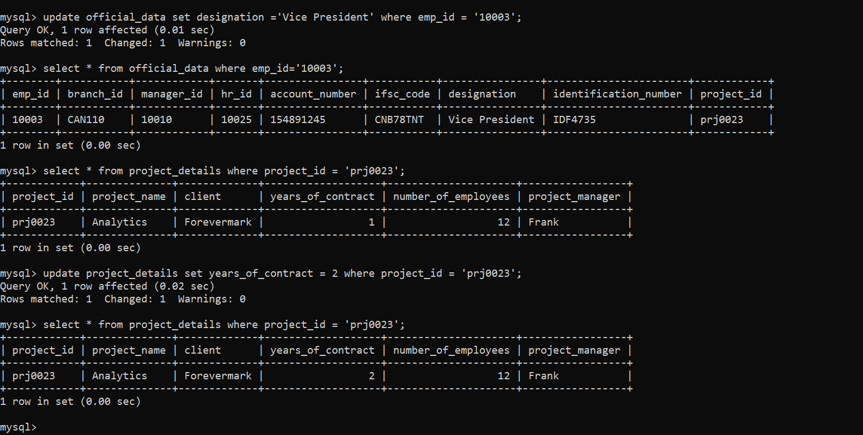

==================================================================================

**Delete Statement :**

*delete from emp_education where emp_id='10018';*

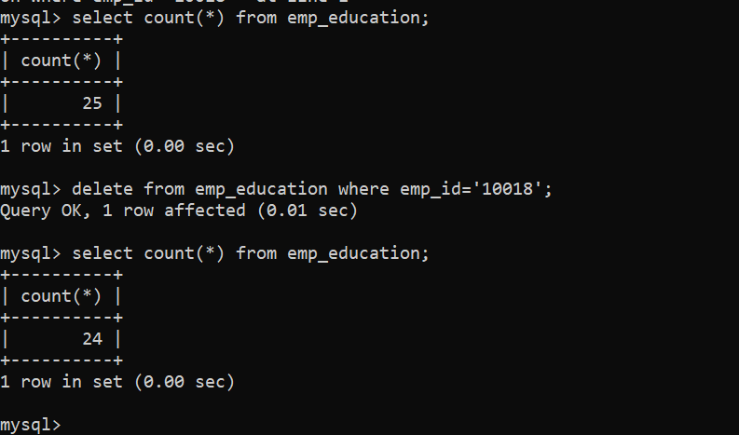

===================================================================================

**Select statement :**

*select * from employee where nationality = 'American';*

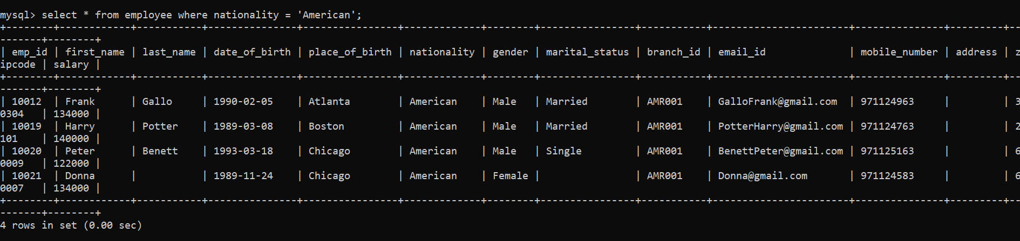

===================================================================================

**Joining three tables:**

*select o.emp_id as emp_id,concat(first_name,' ',last_name) as emp_name,b.ifsc_code as ifsc_code,bank_name,account_number, salary from* ***official_data*** *o left join* ***bank_details*** *b on o.ifsc_code = b.ifsc_code left join* ***employee*** *e on o.emp_id = e.emp_id where lower(b.location) = 'toronto';*

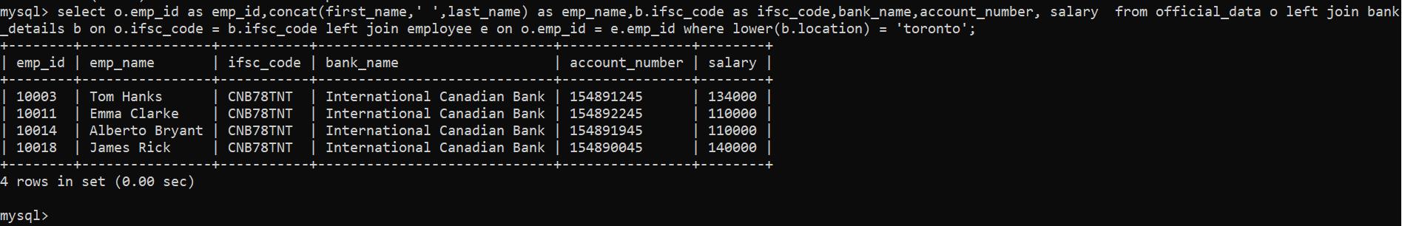

**Left join on two tables :**

*select concat(first_name, ' ',last_name) as employee_name, salary from employee e left join official_data o on e.emp_id = o.emp_id ;*

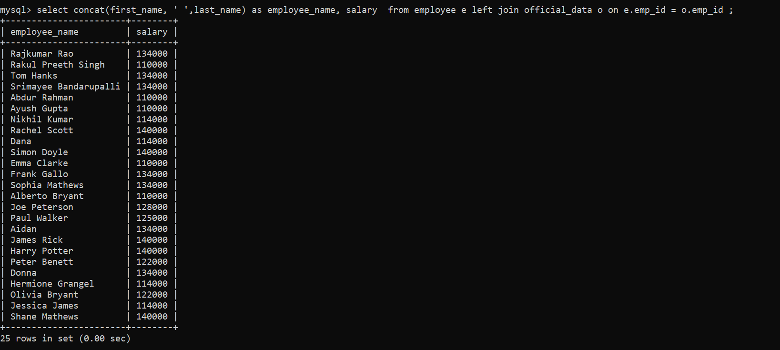

**===================================================================================**

**Summary statements:**

*SELECT * FROM performance_schema.events_statements_summary_global_by_event_name where EVENT_NAME = 'statement/sql/select' limit 1;*

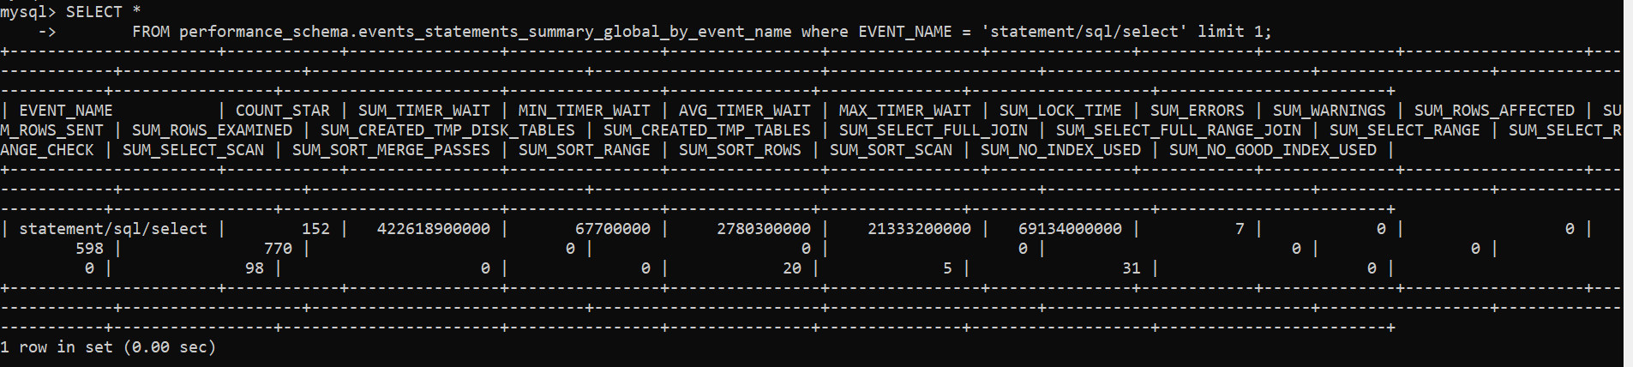

*select * FROM performance_schema.events_statements_summary_global_by_event_name where EVENT_NAME = 'statement/sql/insert' limit 1;*

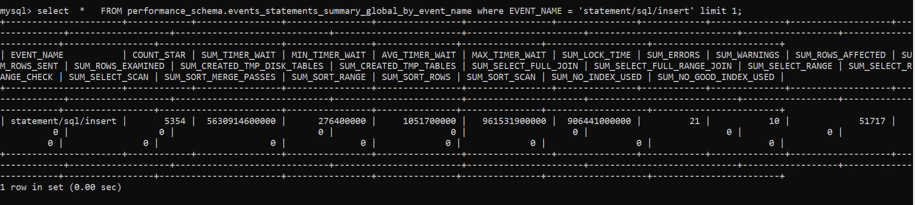

**===================================================================================**

**Multi Table query/Sub query :**

*select emp_id, first_name as Name, Salary, Nationality from employee where emp_id in ( select emp_id from official_data where designation in ('Vice President', 'Assistant VP'));*

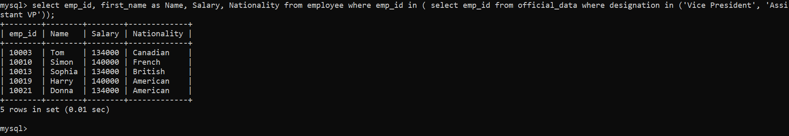

**===================================================================================**

**Query of My Choice:**

*Below is used to fetch all details of the employees whose experience is grater than 13, it uses the join on 4 different tables*

-->

*select e.emp_id, concat(first_name,' ',last_name) employee_name, email_id, date_of_birth, manager_id, bank_name,account_number, o.designation, project_id,exp from* ***employee*** *e left join* ***official_data*** *o on e.emp_id = o.emp_id left join* ***bank_details*** *b on o.ifsc_code =b.ifsc_code left join* ***emp_experience*** *exp on e.emp_id = exp.emp_id where exp > 13;*

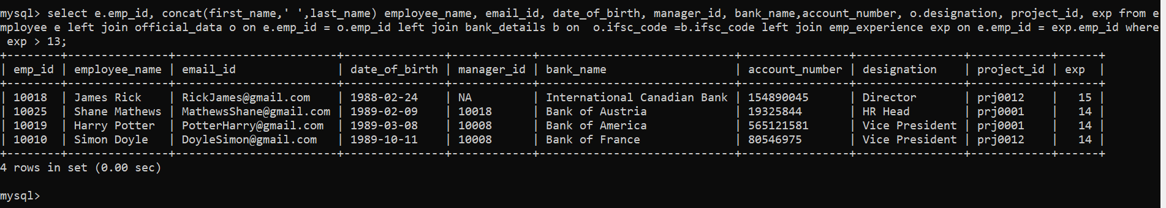

================================================================================

Below is the back to back execution result of all the above twelve queries, I have copy pasted it as I was not able to take the screenshot of all 12 queries in a single screenshot, individual screenshots are already pasted above.

mysql> insert into bank_details(ifsc_code, bank_name, Location, branch_manager) values

-> ('GER01FRFT','Bank of Germany','Frankfurt','Rick Stue');

Query OK, 1 row affected (0.01 sec)

mysql> insert into company_branch(branch_id, branch_head, city, number_of_employees,country) values ('GER100','Simon','Frankfurt',100,'Germany');

Query OK, 1 row affected (0.01 sec)

mysql> update official_data set designation ='Vice President' where emp_id = '10003';

Query OK, 1 row affected (0.01 sec)

Rows matched: 1 Changed: 1 Warnings: 0

mysql> update project_details set years_of_contract = 2 where project_id = 'prj0023';

Query OK, 1 row affected (0.01 sec)

Rows matched: 1 Changed: 1 Warnings: 0

mysql> delete from emp_education where emp_id='10018

'> ;

'> ';

Query OK, 0 rows affected (0.00 sec)

mysql> select * from employee where nationality = 'American';

+--------+------------+-----------+---------------+----------------+-------------+--------+----------------+-----------+-----------------------+---------------+---------+---------+--------+

| emp_id | first_name | last_name | date_of_birth | place_of_birth | nationality | gender | marital_status | branch_id | email_id | mobile_number | address | zipcode | salary |

+--------+------------+-----------+---------------+----------------+-------------+--------+----------------+-----------+-----------------------+---------------+---------+---------+--------+

| 10012 | Frank | Gallo | 1990-02-05 | Atlanta | American | Male | Married | AMR001 | GalloFrank@gmail.com | 971124963 | | 30304 | 134000 |

| 10019 | Harry | Potter | 1989-03-08 | Boston | American | Male | Married | AMR001 | PotterHarry@gmail.com | 971124763 | | 2101 | 140000 |

| 10020 | Peter | Benett | 1993-03-18 | Chicago | American | Male | Single | AMR001 | BenettPeter@gmail.com | 971125163 | | 60009 | 122000 |

| 10021 | Donna | | 1989-11-24 | Chicago | American | Female | | AMR001 | Donna@gmail.com | 971124583 | | 60007 | 134000 |

+--------+------------+-----------+---------------+----------------+-------------+--------+----------------+-----------+-----------------------+---------------+---------+---------+--------+

4 rows in set (0.00 sec)

mysql> select o.emp_id as emp_id,concat(first_name,' ',last_name) as emp_name,b.ifsc_code as ifsc_code,bank_name,account_number, salary from official_data o left join bank_details b on o.ifsc_code = b.ifsc_code left join employee e on o.emp_id = e.emp_id where lower(b.location) = 'toronto';

+--------+----------------+-----------+-----------------------------+----------------+--------+

| emp_id | emp_name | ifsc_code | bank_name | account_number | salary |

+--------+----------------+-----------+-----------------------------+----------------+--------+

| 10003 | Tom Hanks | CNB78TNT | International Canadian Bank | 154891245 | 134000 |

| 10011 | Emma Clarke | CNB78TNT | International Canadian Bank | 154892245 | 110000 |

| 10014 | Alberto Bryant | CNB78TNT | International Canadian Bank | 154891945 | 110000 |

| 10018 | James Rick | CNB78TNT | International Canadian Bank | 154890045 | 140000 |

+--------+----------------+-----------+-----------------------------+----------------+--------+

4 rows in set (0.01 sec)

mysql> select concat(first_name, ' ',last_name) as employee_name, salary from employee e left join official_data o on e.emp_id = o.emp_id ;

+-----------------------+--------+

| employee_name | salary |

+-----------------------+--------+

| Rajkumar Rao | 134000 |

| Rakul Preeth Singh | 110000 |

| Tom Hanks | 134000 |

| Srimayee Bandarupalli | 134000 |

| Abdur Rahman | 110000 |

| Ayush Gupta | 110000 |

| Nikhil Kumar | 114000 |

| Rachel Scott | 140000 |

| Dana | 114000 |

| Simon Doyle | 140000 |

| Emma Clarke | 110000 |

| Frank Gallo | 134000 |

| Sophia Mathews | 134000 |

| Alberto Bryant | 110000 |

| Joe Peterson | 128000 |

| Paul Walker | 125000 |

| Aidan | 134000 |

| James Rick | 140000 |

| Harry Potter | 140000 |

| Peter Benett | 122000 |

| Donna | 134000 |

| Hermione Grangel | 114000 |

| Olivia Bryant | 122000 |

| Jessica James | 114000 |

| Shane Mathews | 140000 |

+-----------------------+--------+

25 rows in set (0.00 sec)

mysql> SELECT * FROM performance_schema.events_statements_summary_global_by_event_name where EVENT_NAME = 'statement/sql/select' limit 1;

+----------------------+------------+----------------+----------------+----------------+----------------+---------------+------------+--------------+-------------------+---------------+-------------------+-----------------------------+------------------------+----------------------+----------------------------+------------------+------------------------+-----------------+-----------------------+----------------+---------------+---------------+-------------------+------------------------+

| EVENT_NAME | COUNT_STAR | SUM_TIMER_WAIT | MIN_TIMER_WAIT | AVG_TIMER_WAIT | MAX_TIMER_WAIT | SUM_LOCK_TIME | SUM_ERRORS | SUM_WARNINGS | SUM_ROWS_AFFECTED | SUM_ROWS_SENT | SUM_ROWS_EXAMINED | SUM_CREATED_TMP_DISK_TABLES | SUM_CREATED_TMP_TABLES | SUM_SELECT_FULL_JOIN | SUM_SELECT_FULL_RANGE_JOIN | SUM_SELECT_RANGE | SUM_SELECT_RANGE_CHECK | SUM_SELECT_SCAN | SUM_SORT_MERGE_PASSES | SUM_SORT_RANGE | SUM_SORT_ROWS | SUM_SORT_SCAN | SUM_NO_INDEX_USED | SUM_NO_GOOD_INDEX_USED |

+----------------------+------------+----------------+----------------+----------------+----------------+---------------+------------+--------------+-------------------+---------------+-------------------+-----------------------------+------------------------+----------------------+----------------------------+------------------+------------------------+-----------------+-----------------------+----------------+---------------+---------------+-------------------+------------------------+

| statement/sql/select | 176 | 517331900000 | 67700000 | 2939300000 | 21333200000 | 80953000000 | 10 | 0 | 0 | 1111 | 1448 | 0 | 0 | 0 | 0 | 0 | 0 | 117 | 0 | 0 | 20 | 5 | 41 | 0 |

+----------------------+------------+----------------+----------------+----------------+----------------+---------------+------------+--------------+-------------------+---------------+-------------------+-----------------------------+------------------------+----------------------+----------------------------+------------------+------------------------+-----------------+-----------------------+----------------+---------------+---------------+-------------------+------------------------+

1 row in set (0.00 sec)

mysql> select * FROM performance_schema.events_statements_summary_global_by_event_name where EVENT_NAME = 'statement/sql/insert' limit 1;

+----------------------+------------+----------------+----------------+----------------+----------------+---------------+------------+--------------+-------------------+---------------+-------------------+-----------------------------+------------------------+----------------------+----------------------------+------------------+------------------------+-----------------+-----------------------+----------------+---------------+---------------+-------------------+------------------------+

| EVENT_NAME | COUNT_STAR | SUM_TIMER_WAIT | MIN_TIMER_WAIT | AVG_TIMER_WAIT | MAX_TIMER_WAIT | SUM_LOCK_TIME | SUM_ERRORS | SUM_WARNINGS | SUM_ROWS_AFFECTED | SUM_ROWS_SENT | SUM_ROWS_EXAMINED | SUM_CREATED_TMP_DISK_TABLES | SUM_CREATED_TMP_TABLES | SUM_SELECT_FULL_JOIN | SUM_SELECT_FULL_RANGE_JOIN | SUM_SELECT_RANGE | SUM_SELECT_RANGE_CHECK | SUM_SELECT_SCAN | SUM_SORT_MERGE_PASSES | SUM_SORT_RANGE | SUM_SORT_ROWS | SUM_SORT_SCAN | SUM_NO_INDEX_USED | SUM_NO_GOOD_INDEX_USED |

+----------------------+------------+----------------+----------------+----------------+----------------+---------------+------------+--------------+-------------------+---------------+-------------------+-----------------------------+------------------------+----------------------+----------------------------+------------------+------------------------+-----------------+-----------------------+----------------+---------------+---------------+-------------------+------------------------+

| statement/sql/insert | 5357 | 5653879100000 | 276400000 | 1055400000 | 961531900000 | 906912000000 | 21 | 10 | 51720 | 0 | 0 | 0 | 0 | 0 | 0 | 0 | 0 | 0 | 0 | 0 | 0 | 0 | 0 | 0 |

+----------------------+------------+----------------+----------------+----------------+----------------+---------------+------------+--------------+-------------------+---------------+-------------------+-----------------------------+------------------------+----------------------+----------------------------+------------------+------------------------+-----------------+-----------------------+----------------+---------------+---------------+-------------------+------------------------+

1 row in set (0.00 sec)

mysql> select emp_id, first_name as Name, Salary, Nationality from employee where emp_id in ( select emp_id from official_data where designation in ('Vice President', 'Assistant VP'));

+--------+--------+--------+-------------+

| emp_id | Name | Salary | Nationality |

+--------+--------+--------+-------------+

| 10003 | Tom | 134000 | Canadian |

| 10010 | Simon | 140000 | French |

| 10013 | Sophia | 134000 | British |

| 10019 | Harry | 140000 | American |

| 10021 | Donna | 134000 | American |

+--------+--------+--------+-------------+

5 rows in set (0.00 sec)

mysql> select e.emp_id, concat(first_name,' ',last_name) employee_name, email_id, date_of_birth, manager_id, bank_name,account_number, designation, project_id,exp from employee e left join official_data o on e.emp_id = o.emp_id left join bank_details b on o.ifsc_code =b.ifsc_code left join emp_experience exp on e.emp_id = exp.emp_id where exp > 13;

ERROR 1052 (23000): Column 'designation' in field list is ambiguous

mysql> select e.emp_id, concat(first_name,' ',last_name) employee_name, email_id, date_of_birth, manager_id, bank_name,account_number, o.designation, project_id,exp from employee e left join official_data o on e.emp_id = o.emp_id left join bank_details b on o.ifsc_code =b.ifsc_code left join emp_experience exp on e.emp_id = exp.emp_id where exp > 13;

+--------+---------------+------------------------+---------------+------------+-----------------------------+----------------+----------------+------------+------+

| emp_id | employee_name | email_id | date_of_birth | manager_id | bank_name | account_number | designation | project_id | exp |

+--------+---------------+------------------------+---------------+------------+-----------------------------+----------------+----------------+------------+------+

| 10018 | James Rick | RickJames@gmail.com | 1988-02-24 | NA | International Canadian Bank | 154890045 | Director | prj0012 | 15 |

| 10025 | Shane Mathews | MathewsShane@gmail.com | 1989-02-09 | 10018 | Bank of Austria | 19325844 | HR Head | prj0001 | 14 |

| 10019 | Harry Potter | PotterHarry@gmail.com | 1989-03-08 | 10008 | Bank of America | 565121581 | Vice President | prj0001 | 14 |

| 10010 | Simon Doyle | DoyleSimon@gmail.com | 1989-10-11 | 10008 | Bank of France | 80546975 | Vice President | prj0012 | 14 |

+--------+---------------+------------------------+---------------+------------+-----------------------------+----------------+----------------+------------+------+

4 rows in set (0.00 sec)